**DEPARTMENT OF MECHANICAL ENGINEERING  
  
Subject: Fundamentals of Programming  
LAB TASK  
Submitted by: Muhammad Maaz  
Registration number: 479510  
Semester No. 1  
Date: October 19, 2023**

**FIRST PROGRAM**

#include<iostream>

using namespace std;

int main() {

int n,sum = 0;

cout << "Enter the number of natural numbers to sum: "<<endl;

cin >> n;

for (int i=1;i<=n;i++){

sum += i;

}

cout << "The sum of the first " << n << " natural numbers is: " <<endl<< sum << endl;

return 0;

}

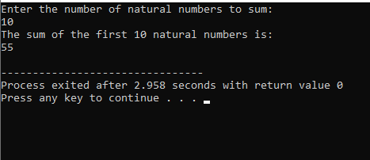

**SECOND PROGRAM**

#include<iostream>

using namespace std;

int main(){

int i=0;

int table=5,multiply;

while(i<11){

cout<<"5x"<< i<<"="<<table*i<<endl;

i++;

}

}

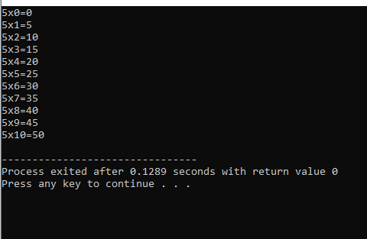

**THIRD PROGRAM**

#include <iostream>

using namespace std;

int main() {

int n, f=1 ;

cout << "Enter a number to find the factorial of: "<<endl;

cin >> n;

for (int i = 1; i <= n; i++) {

f *= i;

}

cout << "The factorial of " << n << " is: "<<endl << f << endl;

return 0;

}

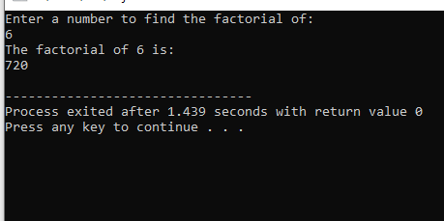

**FOURTH PROGRAM**

#include <iostream>

using namespace std;

int main() {

int n;

cout << "Enter the number of terms: "<<endl;

cin >> n;

int a = 0;

int b = 1;

cout << "The Fibonacci sequence is: "<<endl;

for (int i = 0; i < n; i++) {

cout << a << " ";

int temp = a;

a = b;

b = temp + b;

}

cout << endl;

return 0;

}

